**INDEX**

|  |  |  |  |
| --- | --- | --- | --- |
| **CHAPTER NO** |  | **TOPIC** | **PAGE NO** |
| **1** |  | **INTRODUCTION** |  |
|  | 1.1 | CLIENTS/ORGANIZATION PROFILE | 1 |
|  | 1.2 | NEED FOR SYSTEM | 2 |
|  | 1.3 | SCOPE AND FEASIBILITY OF WORK | 3 |
|  | 1.4 | OPERATING ENVIRONMENT-H/W & S/W | 4 |
|  | 1.5 | ARCHITECTURE OF SYSTEM | 5 |
|  | 1.6 | DETAIL DESCRIPTION OF TECHNOLOGY USED | 6 |
| **2** |  | **PROPOSED SYSTEM** |  |
|  | 2.1 | PROPOSED SYSTEM | 11 |
|  | 2.1 | OBJECTIVES OF SYSTEM | 12 |
|  | 2.3 | USER REQUIREMENTS | 12 |
| **3** |  | **ANALYSIS AND DESIGN** |  |
|  | 3.1 | TABLE SPECIFICATIONS(DATABASE) | 13 |
|  | 3.2 | ERD | 16 |
|  | 3.3 | OBJECT DIAGRAM | 17 |
|  | 3.4 | CLASS DIAGRAM | 18 |
|  | 3.5 | USECASE DIAGRAM | 19 |
|  | 3.7 | WEBSITE MAP DIAGRAM | 20 |
| **4** |  | **USER MANUAL** |  |
|  | 4.1 | USER INTERFACE DESIGN(SCREENS) | 21 |
|  | 4.2 | CODING | 25 |
| 5 | 5.1 | CONCLUSION | 29 |
|  | 5.2 | LIMITATIONS | 29 |
|  | 5.3 | FUURE ENHANCEMENT | 29 |
| **6** |  | **BIBLIOGRAPHY** | 30 |
|  | 6.2 | **ANNEXURE : SAMPLE PROGRAM CODE** | 1 |

**CHAPTER 1**

**INTRODUCTION**

* 1. **ORGANIZATION PROFILE:**

**Name:** Jijai Blood Bank Center

**Location:** Sambhaji Umrekar Heights Shahaji Market, Guru Gobind Singh Ji Road, Nanded, Maharashtra 431602

**Established Year:** 2021

**External Guide:**

**Orgaization:** Established in the year 2021, Jijai Blood Centre in Shivaji Nagar Nanded, it is a top player in the category Fresh Frozen Plasma Blood Banks in the Nanded. This well-known establishment acts as a one-stop destination servicing customers both local and from other parts of Nanded. The belief that customer satisfaction is as important as their products and services, have helped this establishment garner a vast base of customers, which continues to grow by the day. In the near future, this business aims to expand its line of products and services and cater to a larger client base.

Jijai Blood Centre is a commendable service. The facility is well-sanitised, ensuring a safe and hygienic environment. The efficient service provided by the staff is truly impressive. They are quick and attentive, making the entire process hassle-free. Moreover, the commitment to great service is evident in their dedication to saving lives through blood donation. Overall, Jijai Blood Centre deserves high praise for their excellent work in serving the community

* 1. **NEED FOR SYSTEM:**

Blood banks are an important part of the healthcare industry. Blood collected from donors is a vital resource for surgeries, emergencies and treatments. Therefore, at the management end there are some necessary steps to maintain the records of every individual including users/patients but maintaining the records on paper is very difficult so, it is necessary to have a computerized system that manages all these issues. This system also provides excellent security of data to its users. The system will help to operate the blood, blood groups management effectively in the context of handling the details of users.

* 1. **SCOPE & FEASIBILITY OF WORK:** 
     1. **Scope of Work:** The main objective of this specification is to support the automated tracking of blood products from the initial ordering of blood transfusion for a patient.

**The scope of the specification includes the following scenarios,**

1. Routine blood transfusion.

2. Transfusion for special requirements.

3. Emergency issue of blood**.**

**Donor: -**

* The donor will be able to register to the portal.
* The new user/patient visits the website and fills the details and it will be stored for future reference.
* The user/patient requests for blood and also searches for a donor.

**Patient: -**

* The Patient can login to the system.
* The Patient will be able to see their profile.
* The Patient will be able to choose the category for blood group.
* The Patient receives the blood from the bank if there is a stock of that blood group which want to the Patient.

**Admin**

* Admin will be able to keep information of their users or patients.
* Admin will be responsible for keying the received data into the system.
* Admin can see the information of the new donor.
* Admin edit, delete and list the details of the donor, also manages the stock.
* Admin sees the user's request for blood and manages the request which is completed.

**1.3.2 Feasibility of Work**

**1.3.2.1 Technical Feasibility:**

The proposed system is developed using HTML5, CSS3 as front-end wool and JAVA and JSP as the back end. The proposed system needs a web Server Ee. Apache-Tomcat 10.1.1 is used to serve the requests submitted by the users. The Web browser is used to view the web page that is available within the Windows operating system itself. The proposed system will run under Microsoft Windows 7 or above. Our proposed system will be technically because any additional hardware of software requirement will not to be needed for it. All the required hardware and software are readily available in the market. Hence the system is technically feasible.

**1.3.2.2 Operational Feasibility:**

Operational feasibility refers to the measure of solving problems with the help of new proposed system. The users can register/login themselves to the online blood bank web portal. The proposed system after implementation will satisfy the required goals besides providing many other facilities. The system will be easy to understand Atomics validation of input will enhance to operational feasibility further more. Our output screens are familiar with their existing data processing environment from the beginning system operations will be made easy for them. Thus, the system will be operationally feasible.

**1.3.2.3 Economic Feasibility:**

The total cost incurred for development and the implementation will be less than that of the previous system. The system will be economically feasible because of the reasons like we are going to use software. The cost for hardware will be incurred with the specification as discussed in the technical feasibility. After detailed system will be made available freely and whatever the cost incurred, it will be very less to benefits.

* 1. **OPERATING ENVIRONMENT – HARDWARE & SOFTWARE:**

|  |  |
| --- | --- |
| **Server Side** | |
| Operating System | Microsoft Windows 10 and onwards |
| Memory RAM | 2 GB and onwards |
| Browser Software | Google Chrome and compatible browser |
| Database | MySQL 8.1.12 |
| Front End | HTML, CSS and JavaScript |
| Back-end | PHP 5.2.1 |
| Server | XAMPP v3.3.0 |

|  |  |
| --- | --- |
| **Client Side** | |
| Operating System | Microsoft Windows 10 and onwards |
| Memory RAM | 2 GB and onwards |
| Browser Software | Google Chrome and compatible |
| Network | Active Internet Connection |

* 1. **ARCHITECTURE OF SYSTEM:**

The architecture of an E-blood bank system project can be divided into several components:

1. **User Interface:**

This is the front-end component that allows users to interact with the system. It includes web and mobile interfaces for donors, recipients, and admin.

1. **Application Logic:**

The core functionality of the system, including donor registration, blood inventory management, blood request processing, and notifications. It may include business logic and algorithms for matching blood donors with recipients.

1. **Database:**

A database management system to store and manage data related to blood donors, recipients, blood types, inventory, and historical records.

1. **Authentication and Security:**

Ensures that user data is secure and only accessible to authorized personnel. It includes user authentication, role-based access control, and data encryption.

1. **Inventory Management:**

This component focuses on monitoring and managing the available blood supply, including tracking expiration dates and ensuring proper storage conditions.

**6. Backup and Recovery:**

Implements mechanisms for regular data backups and disaster recovery in case of system failures.

**7. Hardware Infrastructure:**

Servers, storage, and networking components to support the system, hosted either on-premises or in the cloud.

* 1. **DETAIL DESCRIPTION OF TECHNOLOGY USED:**
* **HTML**

HTML stands for Hypertext Markup Language. It is used to design web pages using a

markup language. It is the combination of Hypertext and Markup language. Hypertext

defines the connection between the web pages. A markup language is used to define the

text document within tag which defines the structure of web pages. It is a markup language that is used by the browser to act upon text, images, and other content to display in the required format.

It helps to structure our website well. The way a skeleton system gives a structure to the human body, in a similar manner, it acts as a skeleton for a website, without it a website cannot be made. If you want to work as a Software Developer especially in the Web Development domain, then learning HTML is a must, because without knowledge of it you cannot build a website.

* **Base for creating websites**: It is the basic demand a developer should know while
* building a website from scratch.
* **Learn web development:** It is the first step towards learning Web Development. Once you learn it, you can build simple, static websites very easily.
* **Can become freelancer:** Since web development has the best scope in freelancing,
* therefore, learning it will surely help you to get the best deals of website

development in the market.

* **CSS**

CSS (Cascading Style Sheets) is a style sheet language used to design the web page to

make it attractive. The reason for using this is to simplify the process of making web pages presentable. It allows you to apply styles to web pages. More importantly, it enables you to do this independent of the HTML that makes up each web page.

There are three types of CSS which are given below:

* Inline
* Internal or Embedded
* External

Styling is the essential attribute for any website. It increases the standards and overall look of the website that makes it easier for the user to interact with it. A website can be made without CSS, as styling is must since no user would want to interact with a dull and shabby website. So, for knowing Web Development, learning CSS is mandatory.

* **Base for web development:** HTML and CSS is the basic skill that every web

developer should know. It is the basic skill that is required for building a website.

* **Makes your website look attractive:** A website that's dull and plain will not attract

the user most probably, so adding some style would surely make your website

presentable to the User.

* **Makes the design come live:** A web developer is responsible for making the design

given to him as a live product. It is used for styling to develop the design of the

website.

* **Increases user experience of the website**: A website with a simple yet beautiful

UI would help the users to go through the website easily. It is used to make the user

interface better.

* **More career opportunities:** Since CSS is a basic requirement while learning Web

Development, therefor there are abundant career opportunities for it. As a

freelancer, you can land up too many projects.

* **JavaScript**

JavaScript is the world most popular lightweight, interpreted compiled programming

language. It is also known as scripting language for web pages. It is well-known for the

development of web pages, many non-browser environments also use it. JavaScript can be used for Client-side developments as well as Server-side developments.

JavaScript can be added to your HTML file in two ways:

* Internal JS: We can add JavaScript directly to our HTML. file by writing the code

inside the <script> tag. The <script> tag can either be placed inside the <head> or

the <body> tag according to the requirement.

* External JS: We can write JavaScript code in other file having an extension .js and

then link this file inside the <head> tag of the HTML file in which we want to add

this code.

* **PHP**

The term PHP is stands for Hypertext Preprocessor. It is a server-side scripting language, that is used for web development. It can be easily embedded with HTML files. HTML codes can also be written in a PHP file. The PHP codes are executed on the server- side whereas HTML codes are directly executed on the browser.

It is one of the widely used open-source general-purpose scripting language that is used for back-end Development.

* **Easy to Learn:** It is easier to learn for anyone who has come across to any

programming language for the first time.

* **Free of Cost:** Since it is an open-source language, therefore developers are allowed

to use its components and all methods for free.

* **Flexible:** Since it is a dynamically typed language. Therefore, there are no hard

rules on how to build features using it.

* **Supports nearly all databases:** It supports all the widely used databases including

MySQL

* **Secured:** It has multiple security levels provides us a secure platform for

developing websites as it has multiple security levels.

* **Huge Community Support**: It is loved and used by a huge number of developers.

The developers share their knowledge with other people of the community that

want to know about it.

Syntax of PHP language is similar to C language. It is created by Rasmus Lerdorf and

it appeared in 1995. PHP is being widely utilized in developing web applications and

become one among main languages for developers to make new applications.

However, over years its area of use has shifted and PHP coding language is ranked

among simplest and hottest programming tools for web development thanks to its many

virtues which can be main target of this text. It's considered a really effective

technology that gives a convenient development process with many additional tools to

assist it. PHP is one of the fifth hottest coding language within world.

PHP is getting used widely in developing web-based and other applications across all

domains.

* **Xampp 8.0.9**

XAMPP is the best tool to setup a web server locally and practice web

development. XAMPP is available with Windows, Linux and MAC, and best

of all its free to use. Easy to setup and install Apache distribution containing

MariaDB, PHP, and Perl that works on your own computer system with no

internet connection required.

**Advantages of learning Xampp:**

* It is free and easy to use and easily available for Windows, Linux and Mac

OS.

* It is a beginner’s friendly solution package for full stack web

development.

* It is an open-source software package which gives an easy installation

experience.

**Characteristics of Xampp:**

Xampp is regularly updated to the latest releases of Apache, MariaDB, PHP,

and Perl. It also comes with a number of other modules, including Open SSl,

phpMyAdmin, Media Wiki, Joomla, WordPress and more. Self-contained,

multiple instances of Xampp can exist on a single computer, and any given

instances can be copied from one computer to another. Xampp is offered in both

a full and a standard version (smaller version).

* **MySQL 5.7**

MySQL is the most popular open-source database and of course, Postgres. SQL

is definitely up there. As companies move their data from on prem to cloud,

they usually like to migrate to a cloud native database, or an open-source

database, like MySQL or Postgres sequel, in order to save costs.

**Advantages of learning MySQL:**

Data Protection. It is one of the most popular database management

systems in terms of security and dependability.

* Scalability on Demand.
* High Efficiency.
* 24/7 Uptime
* Outstanding Transactional Support.
* Excellent Workflow Control
* Lower Total Ownership Cost

**Characteristics of MySQL:**

Open-Source. MySQL is open-source, which means this software can be downloaded, used and modified by anyone.

* Quick and Reliable.
* Scalable.
* Data Types.
* Character Sets.
* Secure.
* Support for large databases.
* Client and Utility Programs.

**CHAPTER 2**

**PROPOSED SYSTEM**

**2.1 PROPOSED SYSTEM:**

The major drawback of the existing i.e., Maintaining records of blood, users/application in books will be replaced by web-based application. This proposed system will be much more interactive with the user. It will maintain daily records of users, donors like keeping track of their blood, registration details. The main objective of this project is to support the automated tracking of blood products from the initial ordering of blood transfusion for a patient. The blood donation event schedule is normally advertised to the public so that are aware of the blood campaign period. The public did not have knowledge about blood donation. For using our system that is blood bank system patient can easily find out the blood for an emergency situation.

**Advantages of Proposed System:**

* Proposed will replaced books and any other paper material, which makes blood management to work more efficiently with accuracy of data.
* Proposed system will have registration page for new users as well for existing users.
* Proposed system will be implemented with registration and enquiry about blood which will be available online. So, there will be no need to blood bank for registration/enquiry they can do this anywhere at any time using this web application.
* Proposed system will reduce human errors, as every detail are going to be stored at backend, so there will no error while maintaining records.
* Proposed system will maintain daily records, which is going to be kept tracked by the administrator which makes admin helpful for getting information about the blood for the users and patients as well.

**2.2 OBJECTIVES OF SYSTEMS:**

* To manage the details of the blood, donor, blood group, bloodstock.
* To build an application program to reduce the manual work for managing the blood, donor, blood group.
* To provide a service to users/patient in an efficient manner.
* To maintain enquiry details about the blood groups are the proper way.
* To maintain daily records in proper manner.
* To maintain each and every user/patient record in a systematic manner so that the searching process will be easy.
* To improve the efficiency of blood stack management by alerting the blood bank staff when the blood quantity is below as per level or when the blood stock has expired.
* To provide an efficient donor and blood stock management functions to the blood bank by recording the donor and blood details.

**2.3 USER REQUIREMENTS:**

* The system should make the user and admin to be registered and it should be mandatory.
* The system should provide data accuracy while maintaining the details of users and patients.
* The system should provide the change in login password of admin.
* The system should be able to register the donor by himself.
* The system should be able to register the donor by system admin.
* The system should provide the change in login of donor.
* The system should be capable to change personal, contact details by the donor.
* The system should be capable to send blood donation details to the relevant donors.
* The system should be capable to send blood testing details.

**CHAPTER 3**

**ANALYSIS & DESIGN**

**3.1 TABLE SPECIFICATION (DATABASE)**

**3.1.1**

|  |  |  |  |  |
| --- | --- | --- | --- | --- |
| Table Name | admin | | | |
| Primary Key | **_** | | | |
| Description of table | Admin details are going to store in this table | | | |
| Sr. no. | Field Name | Data type with size | Constraint | Description |
| 1 | id | int(15) | pk | To store id of admin. |
| 2 | name | varchar(45)Not null | Not Null | To store name of admin. |
| 3 | email | varchar(45) | Not Null | To store the email of admin. |
| 4 | password | varchar(45) | Not Null | To store password of admin. |
| 5 | Mobile number | varchar(45) | Not Null | To store mobile number of admin. |

**3.1.2**

|  |  |  |  |  |
| --- | --- | --- | --- | --- |
| Table Name | donations | | | |
| Primary Key | Donor_id | | | |
| Foreign key | _ | | | |
| Description of table | Donors donations are going to store in this table | | | |
| Sr. no. | Field Name | Data type with size | Constraint | Description |
| 1 | id | int(15) | pk | To store id of donations. |
| 2 | donor_id | varchar(45)Not null | Not Null | To store donor_id of donations. |
| 3 | blood_group | varchar(45) | Not Null | To store blood group of donations. |
| 4 | no_units | varchar(45) | Not Null | To store number of units of donations. |
| 5 | disease | varchar(45) | Not Null | To store mobile number of donations. |
| 6 | status | Varchar(45) | Not Null | To store Status of donations. |

**3.1.3**

|  |  |  |  |  |
| --- | --- | --- | --- | --- |
| Table Name | donors | | | |
| Primary Key | id | | | |
| Foreign key | _ | | | |
| Description of table | Donors’ registration details are going to store in this table | | | |
| Sr. no. | Field Name | Data type with size | Constraint | Description |
| 1 | id | int(15) | pk | To store id of donor. |
| 2 | name | varchar(45)Not null | Not Null | To store name of donor. |
| 3 | email | varchar(45) | Not Null | To store the email of donor. |
| 4 | password | varchar(45) | Not Null | To store password of donor. |
| 5 | mobilenumber | varchar(45) | Not Null | To store mobile number of donor. |

**3.1.4**

|  |  |  |  |  |
| --- | --- | --- | --- | --- |
| Table Name | Patients | | | |
| Primary Key | id | | | |
| Description of table | Patients’ details are going to store in this table | | | |
| Sr. no. | Field Name | Data type with size | Constraint | Description |
| 1 | id | int(11) | (PK) | To store id of patient |
| 2 | name | varchar(45) | Not Null | To store name of patient |
| 3 | email | varchar(45) | Not Null | To store email of patient |
| 4 | password | Varchar(45) | Not Null | To store password op patient |
| 5 | Mobile number | varchar(45) | Not Null | To store mobile number of patient |

**3.1.5**

|  |  |  |  |  |
| --- | --- | --- | --- | --- |
| Table Name | requests | | | |
| Primary Key | patient_id | | | |
| Foreign key | _ | | | |
| Description of table | patients’ blood request details are going to store in this table | | | |
| Sr. no. | Field Name | Data type with size | Constraint | Description |
| 1 | id | int(15) | Not Null | To store id of request |
| 2 | Patient_id | int(15) | Primary key | To store patient id of request |
| 3 | blood_group | Varchar(10) | Not Null | To store blood group of request |
| 4 | reason | varchar(50) | Not Null | To store reason of request |
| 5 | status | Varchar(45) | Not Null | To store the status of request |

**3.1.6**

|  |  |  |  |  |
| --- | --- | --- | --- | --- |
| Table Name | stock | | | |
| Primary Key | Bloodgroup | | | |
| Foreign key | _ | | | |
| Description of table | Stock of bloodgroup and its units are going to store in this table | | | |
| Sr. no. | Field Name | Data type with size | Constraint | Description |
| 1 | BloodGroup | varchar(45) | Primary key | To store user bloodgroup |
| 2 | Units | int(11) | Not Null | To store units of blood group |

**3.2Entity Relationship Diagram**

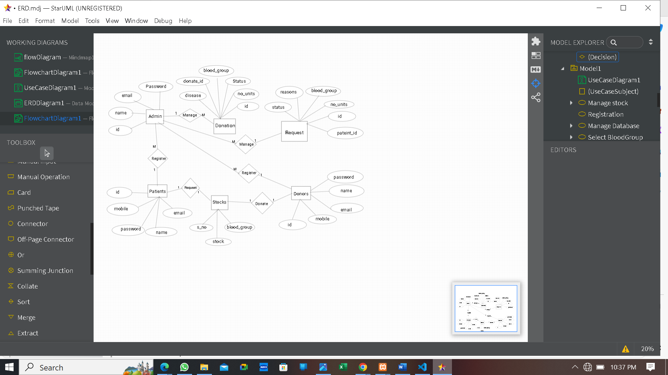

**E-Blood Bank System -ERD**

**3.3 Object Diagram**

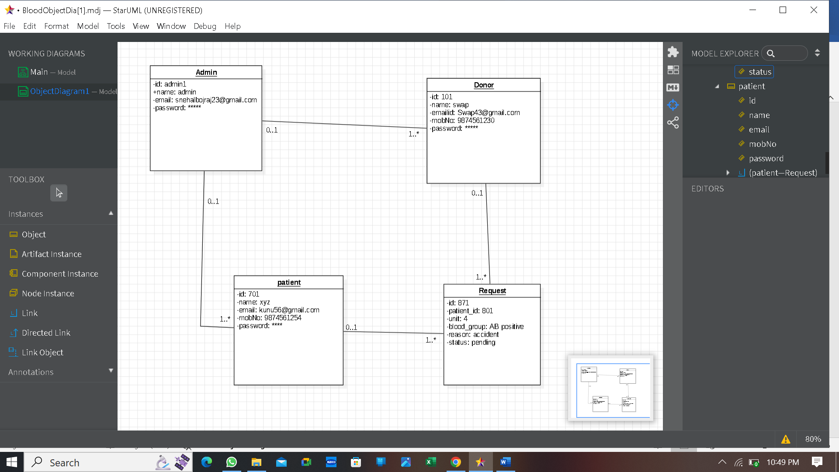

**E-Blood Bank System -Object Diagram**

**3.4 Class Diagram**

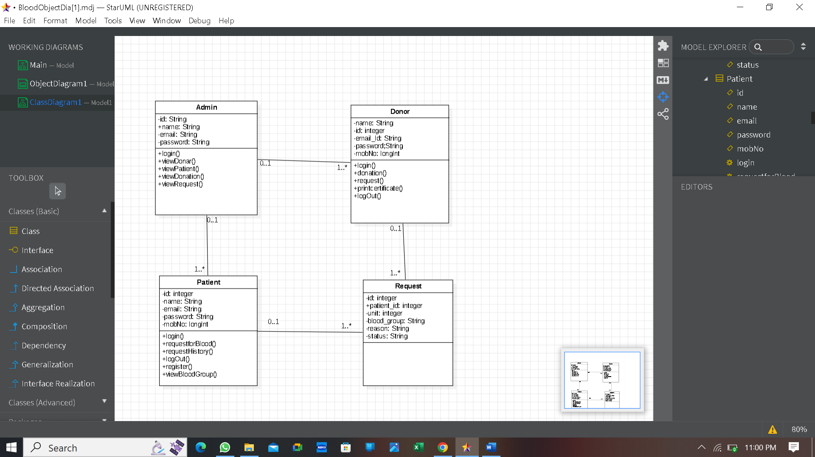

**E-Blood Bank System -Class Diagram**

**3.4 Use Case Diagram**

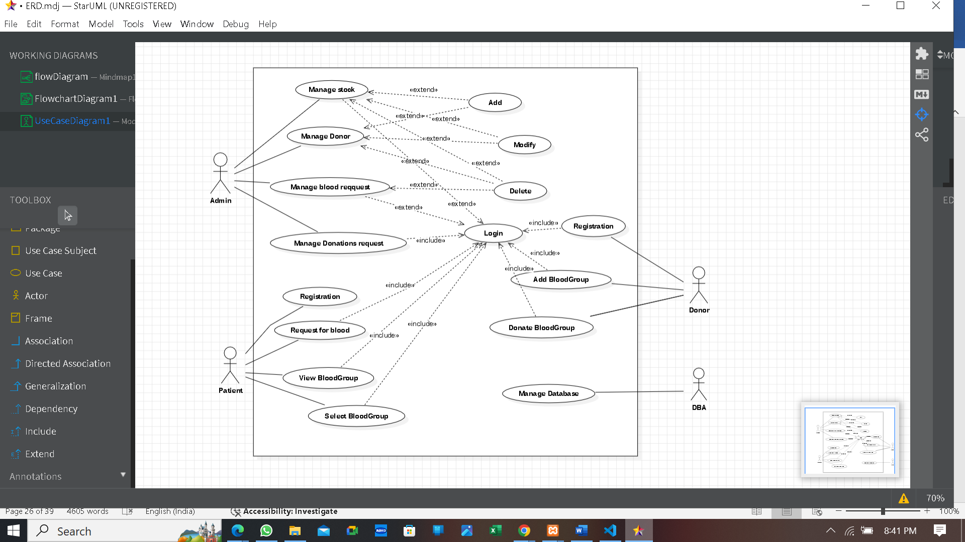

**E-Blood Bank System -Use Case Diagram**

**3.6 Web Site Map Diagram**

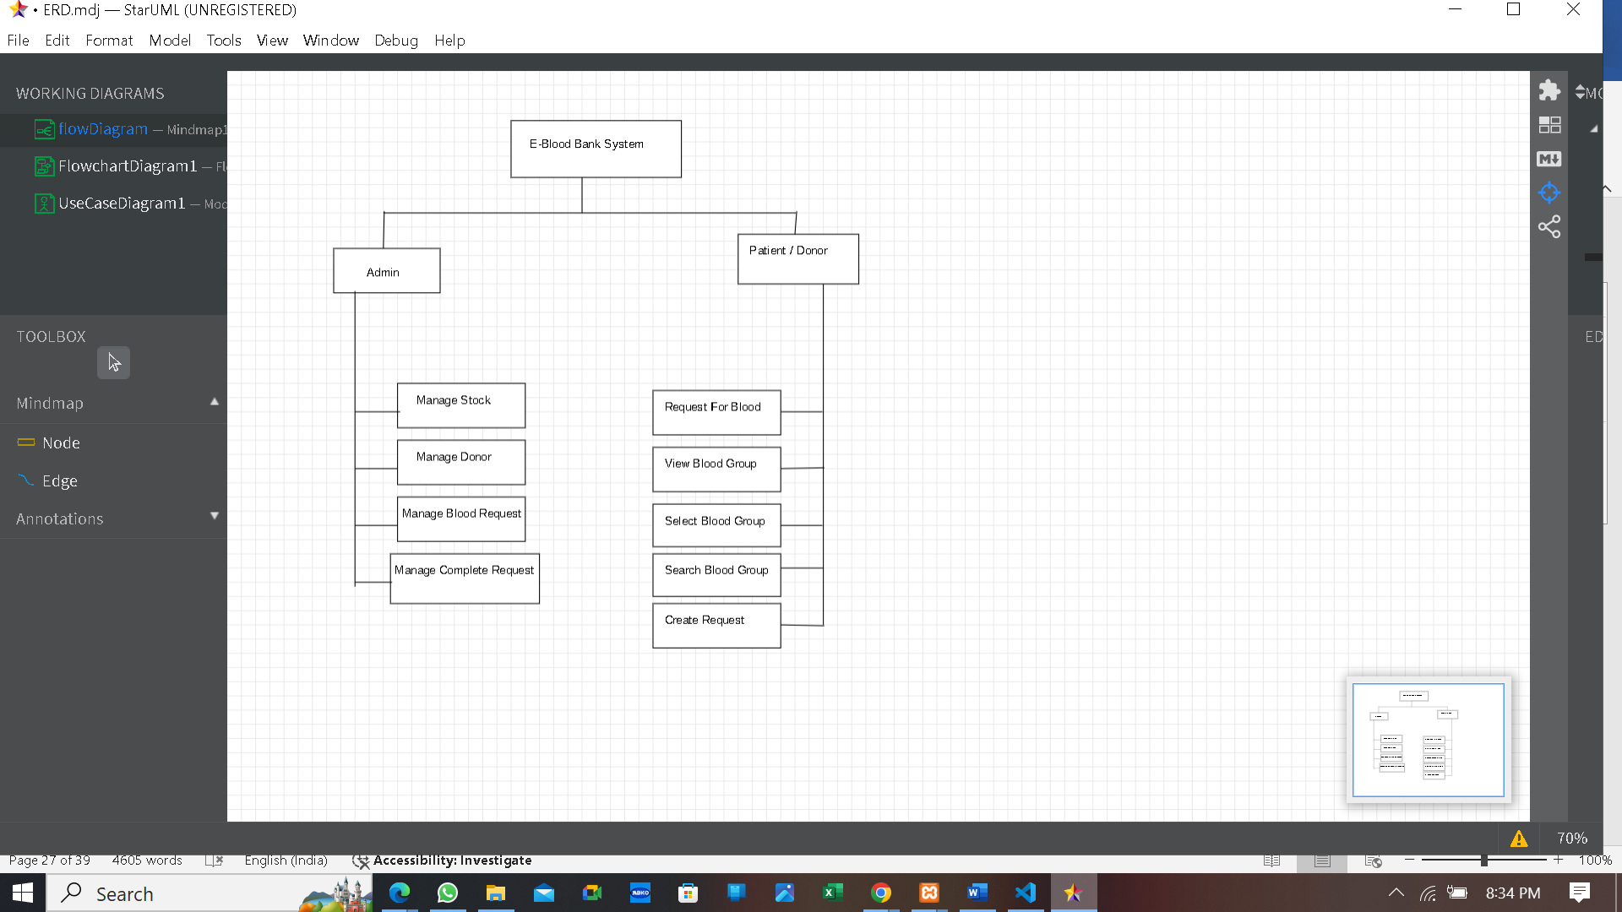

**E-Blood Bank System** - **Web Site Map Diagram**

**CHAPTER 4**

**USER MANUAL**

**4.1 USER INTERFACE DESIGN :**

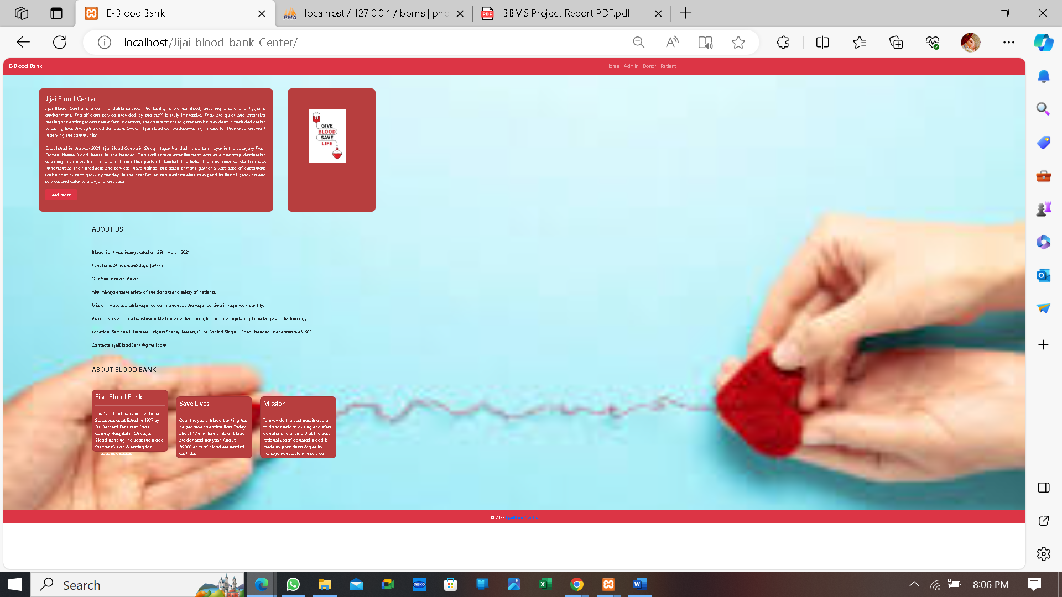**1.Home Page :**

**2.Login Page For Admin :**

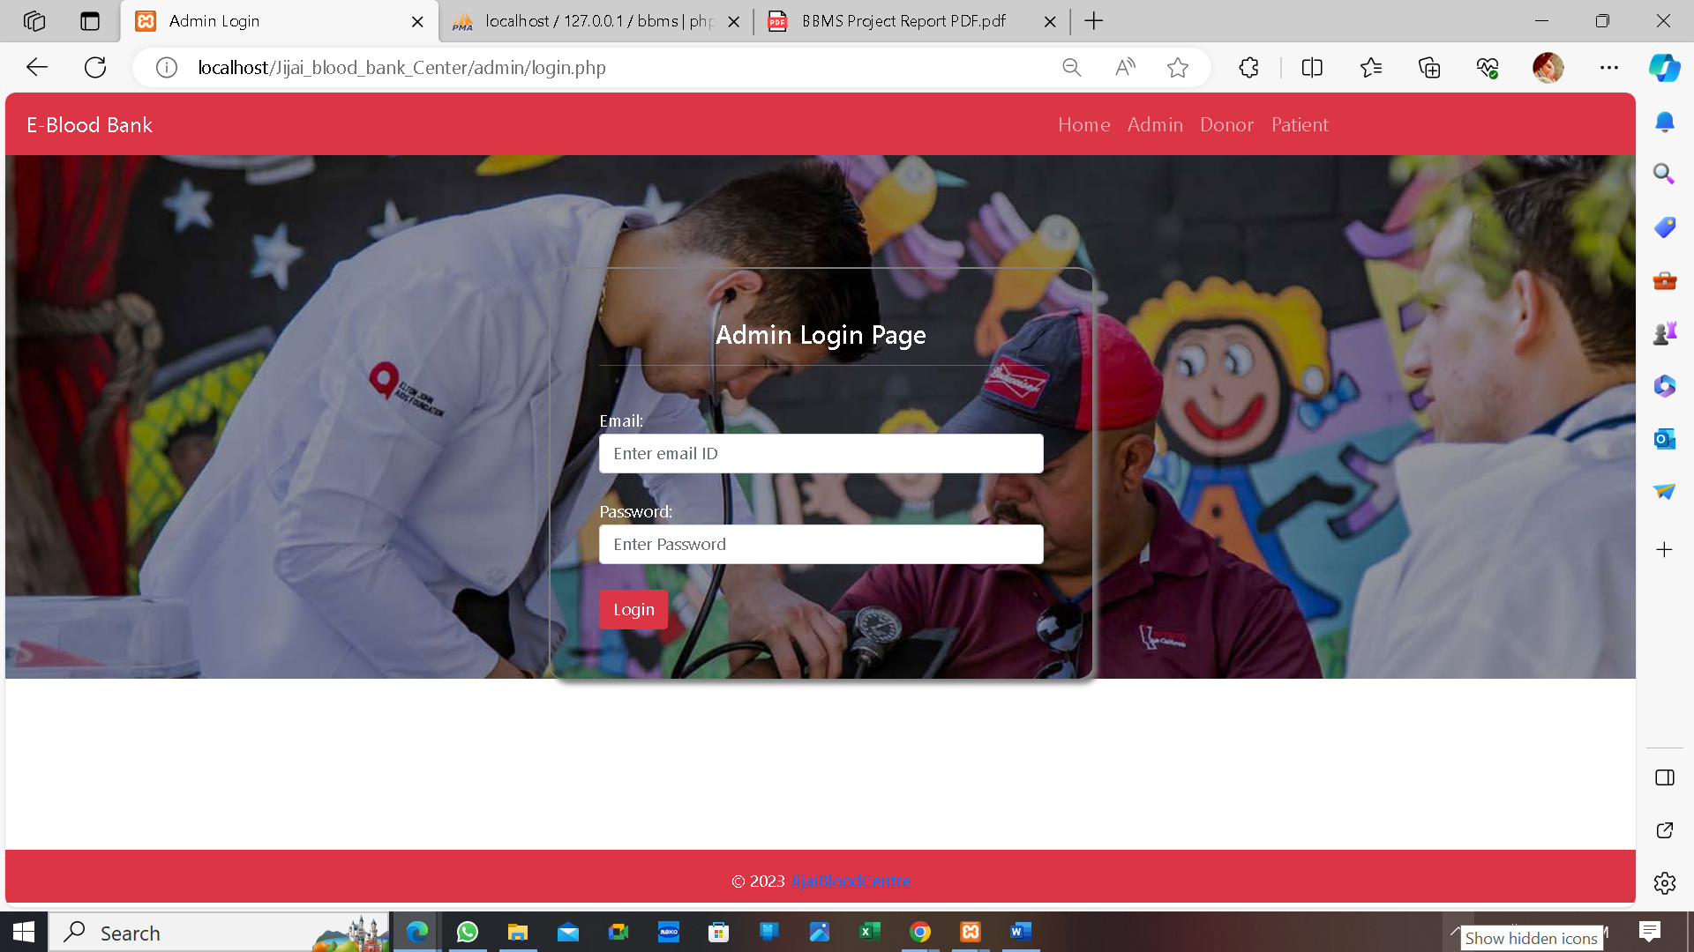

**3. Dashboard for Admin**

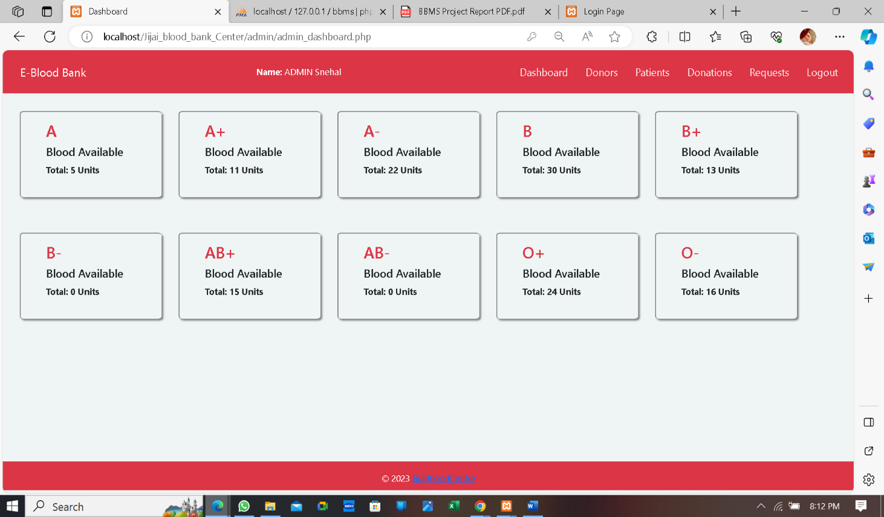

**4. Register Page For Donar & Patient:**

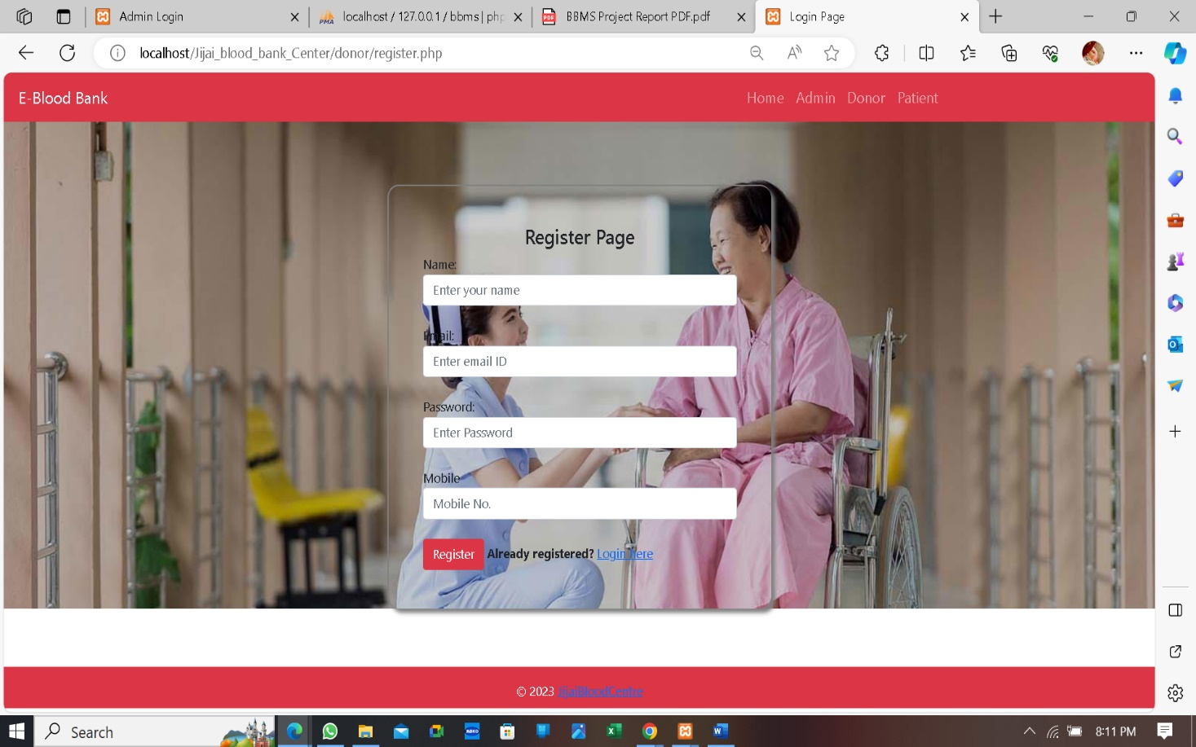

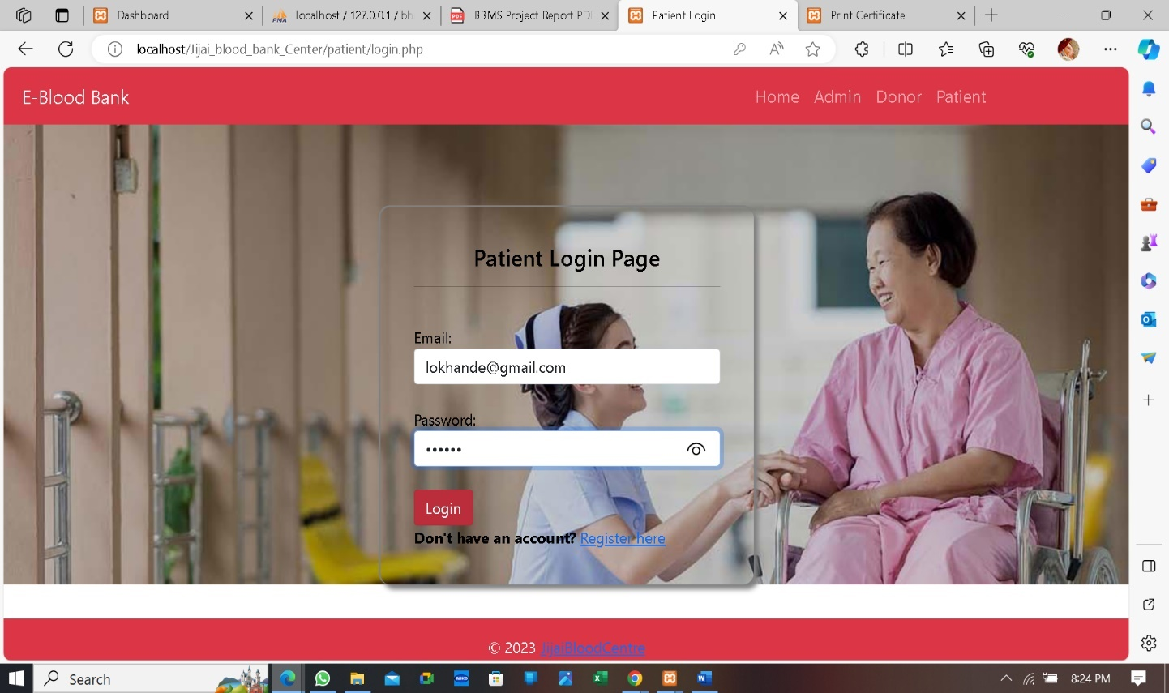**5.LogIn Page for Patient:**

**6.Request for Blood:**

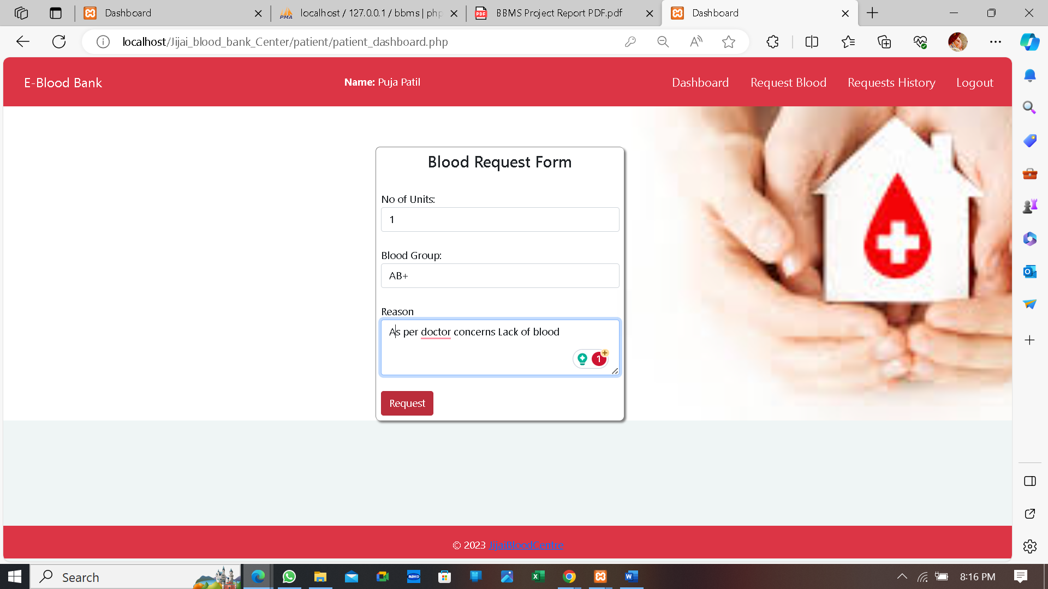

**7.DonorForm:**

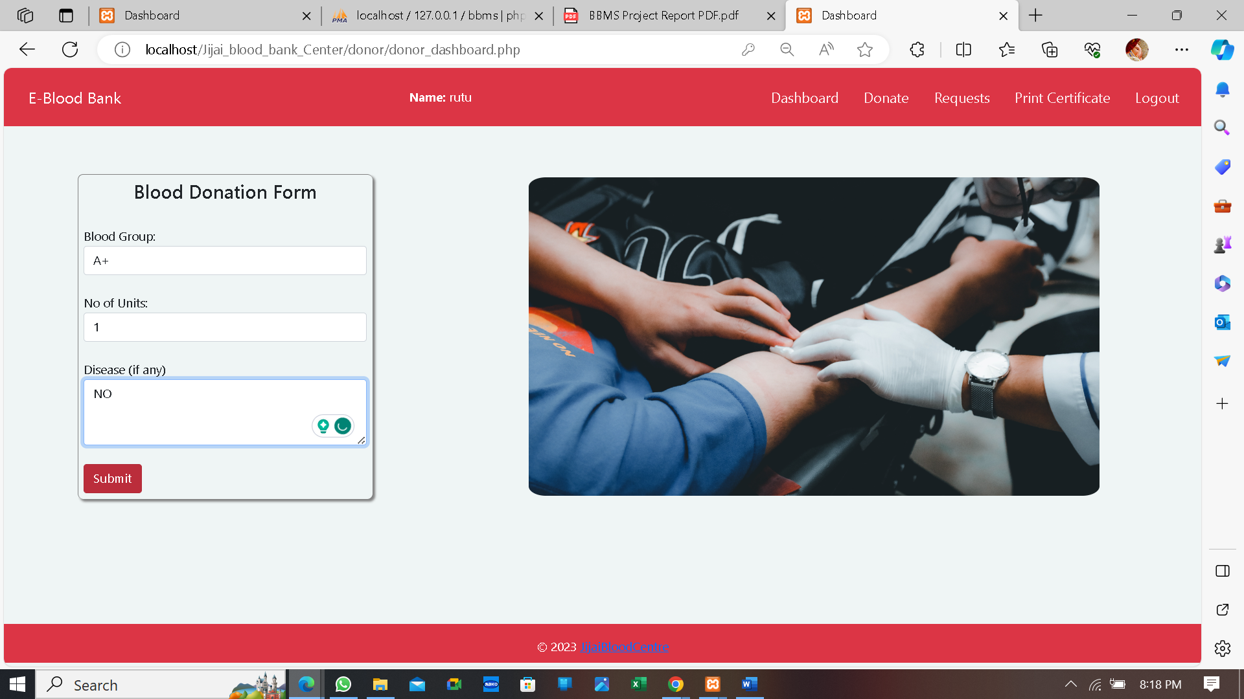

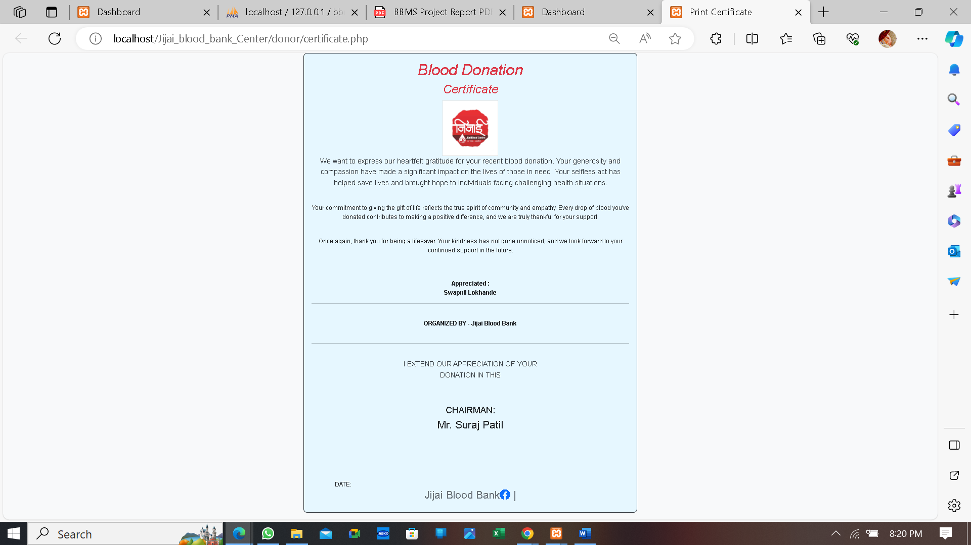**8. Certificate:**

**4.2 CODING:**

**4.2.1 LOGIN PAGE:**

<?php

session_start();

if(isset($_POST['login'])){

include('../includes/connection.php');

$query = "select id,email,password,name from patients where email = '$_POST[email]' AND password = '$_POST[password]'";

$query_run = mysqli_query($connection,$query);

if(mysqli_num_rows($query_run)){

$_SESSION['email'] = $_POST['email'];

while($row = mysqli_fetch_assoc($query_run)){

$_SESSION['name'] = $row['name'];

$_SESSION['uid'] = $row['id'];

}

echo "<script type='text/javascript'>

window.location.href = 'patient_dashboard.php';

</script>";

}

else{

echo "<script type='text/javascript'>

alert('Please enter correct email and password.');

window.location.href = 'login.php';

</script>";

}

}

?>

<!DOCTYPE html>

<html lang="en">

<head>

<meta charset="UTF-8">

<meta http-equiv="X-UA-Compatible" content="IE=edge">

<meta name="viewport" content="width=device-width, initial-scale=1.0">

<title>Patient Login</title>

<!-- Bootstrap files -->

<link rel="stylesheet" href="../bootstrap/css//bootstrap.min.css">

<script src="../bootstrap/js/bootstrap.min.js"></script>

<!-- External CSS file -->

<link rel="stylesheet" href="../css/styles.css">

</head>

<body>

<div class="login-page bk-img" style="background-image: url(img/3.jpg);">

<nav class="navbar navbar-expand-lg navbar-dark bg-danger">

<a class="navbar-brand" href="index.php">E-Blood Bank </a>

<button class="navbar-toggler" type="button" data-toggle="collapse" data-target="#navbarNav" aria-controls="navbarNav" aria-expanded="false" aria-label="Toggle navigation">

<span class="navbar-toggler-icon"></span>

</button>

<div class="collapse navbar-collapse" id="navbarNav">

<ul class="navbar-nav">

<li class="nav-item">

<a class="nav-link" href="../index.php">Home</a>

</li>

<li class="nav-item">

<a class="nav-link" href="../admin/login.php">Admin</a>

</li>

<li class="nav-item">

<a class="nav-link" href="../donor/login.php">Donor</a>

</li> <li class="nav-item">

<a class="nav-link" href="login.php">Patient</a></li>

</ul> </div>

</nav>

<div class="container-fluid">

<div class="row" style="margin-top: 7%;">

<div class="col-md-4 mx-auto" id="login-container">

<style>

body {

color: black;

}

</style>

<center><h4>Patient Login Page</h4></center><hr><br>

<form action="" method="POST">

<div class="form-group">

<label for="email">Email:</label>

<input type="email" class="form-control" name="email" placeholder="Enter email ID" required>

</div><br>

<div class="form-group">

<label for="password">Password:</label>

<input type="password" class="form-control" name="password" placeholder="Enter Password" required>

</div><br>

<input type="submit" class="btn btn-danger" value="Login" name="login">

<br>

<strong>Don't have an account? </strong><a href="register.php">Register here</a>

</form>

</div>

</div>

</div>

<div class="container-fluid">

<div class="row">

<div class="col-md-12 bg-danger" id="footer">

&copy 2023 <a href="mailto:jijaibloodcentre@gmail.com">JijaiBloodCentre</a>

</div>

</div>

</div>

</body>

</html>

**CHAPTER 5**

**CONCLUSION**

**5.1 CONCLUSION:**

The E-Blood Bank System Project has significantly enhanced the overall effectiveness and efficiency of the blood bank. By incorporating features such as electronic donor cards, advanced database management systems, and automated blood testing equipment, the system has revolutionized the blood bank's ability to track and manage blood donations.

Additionally, the system's robust security measures and adherence to industry standards ensure that the blood bank maintains its integrity and reliability. These features have significantly improved the blood bank's capacity to serve the community, resulting in a positive impact on public health.

**5.2 LIMITATIONS:**

* In this System user cannot track in the details information’s about the blood availability.
* Unavailability of information message through mobile services.
* user cannot check their own history.
* Authorities are not available to the user.

**5.3 FUTURE ENHANCEMENT:**

* More user-friendly interface.
* User can have more access through the website.
* Easily know the blood availability.
* Attached mobile facilities like sending messages and important notices.

**CHAPTER 6**

**BIBILOGRAPGHY**

**BIBLIOGRAPHY:**

For the proposed project References are taken from

**Books:**

* PHP for web
* Headfirst PHP & MYSQL

**Websites:**

* [www.geeksforgeeks.org](https://www.geeksforgeeks.org/)
* [www.tutorialspoint.com](http://www.tutorialspoint.com/)
* [www.javatpoint.com](http://www.javatpoint.com/)
* [W3Schools Online Web Tutorials](https://www.w3schools.com/)

**6.2 ANNEXURE ( SAMPLE PROGRAM CODE ) :**

**Request Blood page:**

<?php

session_start();

if(isset($_SESSION['email'])){

?>

<html>

<head>

<style>

.donate-form{

box-shadow: 3px 3px 3px gray;

border-left: 1px solid gray;

border-top: 1px solid gray;

border-radius: 7px;

padding: 7px;

}

</style>

</head>

<body>

<div class="row" style="margin-top: 4%;">

<div class="col-md-3 m-auto donate-form">

<center><h4>Blood Request Form</h4></center><br>

<form action="" method="POST">

<div class="form-group">

<label for="units">No of Units:</label>

<input type="text" class="form-control" name="units" placeholder="No of units (in ml)"> </div><br>

<div class="form-group">

<label for="name">Blood Group:</label>

<select name="bgroup" class="form-control" required>

<option value="">-Select-</option>

<option value="A">A</option>

<option value="A+">A+</option>

<option value="A-">A-</option>

<option value="B">B</option>

<option value="B+">B+</option>

<option value="B-">B-</option>

<option value="AB+">AB+</option>

<option value="AB-">AB-</option>

<option value="O+">O+</option>

<option value="O-">O-</option>

</select>

</div><br>

<div class="form-group">

<label for="">Reason</label>

<textarea name="reason" cols="45" rows="3" class="form-control" placeholder="Mention the reason"></textarea>

</div><br>

<input type="submit" class="btn btn-danger" name="request_blood" value="Request">

</form>

</div> </div>

</body>

</html>

<?php

}

else{

header('Location:login.php');

}

?>